Code 1.1.3 } Write a Python program that prompts the user to enter the side_length of a square and computes the area of the square.

Algorithm :
Step 1 : start
Step 2 : input of side_length
Step 3 : calculating area = side_length * side_length
Step 4 : stop

Code :
Side_length = float(input())
Area = Side_length * Side_length
Print(Area)

Flowchart :
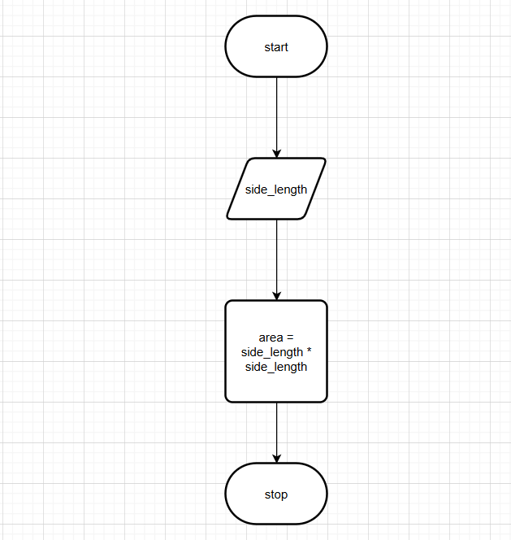

Codetantra :
